CHAPTER 1
INTRODUCTION

  - Introduction to DBMS
Database is a collection of related data. DBMS came into existence in 1960 by Charles. Again in 1960 IBM brought IMS-Information management system. In 1970 Edgor Codd at IBM came with new database called RDBMS. In 1980 then came SQL Architecture- Structure Query Language. In 1980 to 1990 there were advances in DBMS e.g. DB2, ORACLE. A database has the following implicit properties:
- A database represents some aspect of the real world, sometimes called the miniworld or the universe of discourse (UoD). Changes to the miniworld are reflected in the database.
- A database is a logically coherent collection of data with some inherent meaning. A random assortment of data cannot correctly be referred to as a database.
- A database is designed, built, and populated with data for a specific purpose. It has an intended group of users and some preconceived applications in which these users are interested.
In other words, a database has some source from which data is derived, some degree of interaction with events in the real world, and an audience that is actively interested in its contents.
Metadata (meta data, or sometimes meta information) is "data about data", of any sort in any media. An item of metadata may describe a collection of data including multiple content items and hierarchical levels, for example a database schema. In data processing, metadata is definitional data that provides information about or documentation of other data managed within an application or environment. The term should be used with caution as all data is about something, and is therefore metadata.
A database management system (DBMS) is a collection of programs that enables users to create and maintain database. The DBMS is a general-purpose software system that facilitates the process of defining, constructing, manipulating and sharing databases among various users and applications.

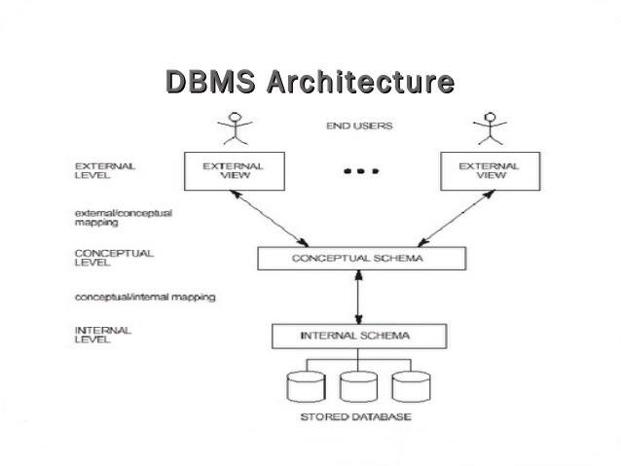

Figure 1.1. Three schema architecture

The Figure 1.1 shows the Three schema architecture of Database Management System, The Three schema architecture consists of three levels of the architecture:
- External Level:
The external level is the view that the individual user of the database has. This view is often a restricted view of the database and the same database may provide a number of different views for different classes of users. In general, the end users
and even the application programmers are only interested in a subset of the database.
- Conceptual Level:
The conceptual view is the information model of the enterprise and contains the view of the whole enterprise without any concern for the physical implementation. The conceptual view is the overall community view of the database and it includes all the information that is going to be represented in the database.
- Internal Level:
The internal view is the view about the actual physical storage of data. It describes what data is stored in database and how.

  - Overview of the project

Project is related to Project Management System.

The project maintains three levels of users: -
Administrator Level, Teacher level and Viewers.

Front end is designed using Java Swings and Xampp is used for Back end.
Main features available in this project are: -
To View of all the project inside the database.
View marks of a particular project identified by its id.
Admin can insert student, team and project details into database, and can view every projects detail as well as every teachers’ detail. Teacher can insert marks into the projects under them, as well as they can view all the projects under them.

    - Problem statement:
To maintain and manipulate the data to be stored in the Project Management database system.

    - Objectives of the project:
- The main objective behind this project is to promote paperless data storage and its maintenance and a move towards digital advancement of data.
- Less retrieval time of project details from vast data.
- More secure as data is stored in a database and can be accessed only by authorized person.
- Student can view their marks instantly.

CHAPTER 2

SYSTEM DESIGN AND METHODOLOGY

2.1. System Architecture

ADMIN
INSERT STUDENT,
TEAM,
PROJECT.

LOGIN

VIEW PROJECTS

VIEWERS
VIEW MARKS
DATABASE

TEACHER
INSERT MARKS INTO PROJECT

LOGIN

VIEW PROJECTS

Figure 2.1. System Architecture of Project Management System

The Figure 2.1 describes the System Architecture of an Project Management System. The architecture consists of a centralized database, which will be accessed by 3 types of users namely: admin and the teacher and students. Both Administrative and Teacher access is implemented through login module with which they can login using their registered username and password.

Once login is successful, the admin can either upload student, project, team details into database or view the projects inside the database. Teachers can insert marks into the projects under them and can also view the projects under them.
Students can view their marks by providing their project id which will be retrieved from the database.

2.2. ER Diagram

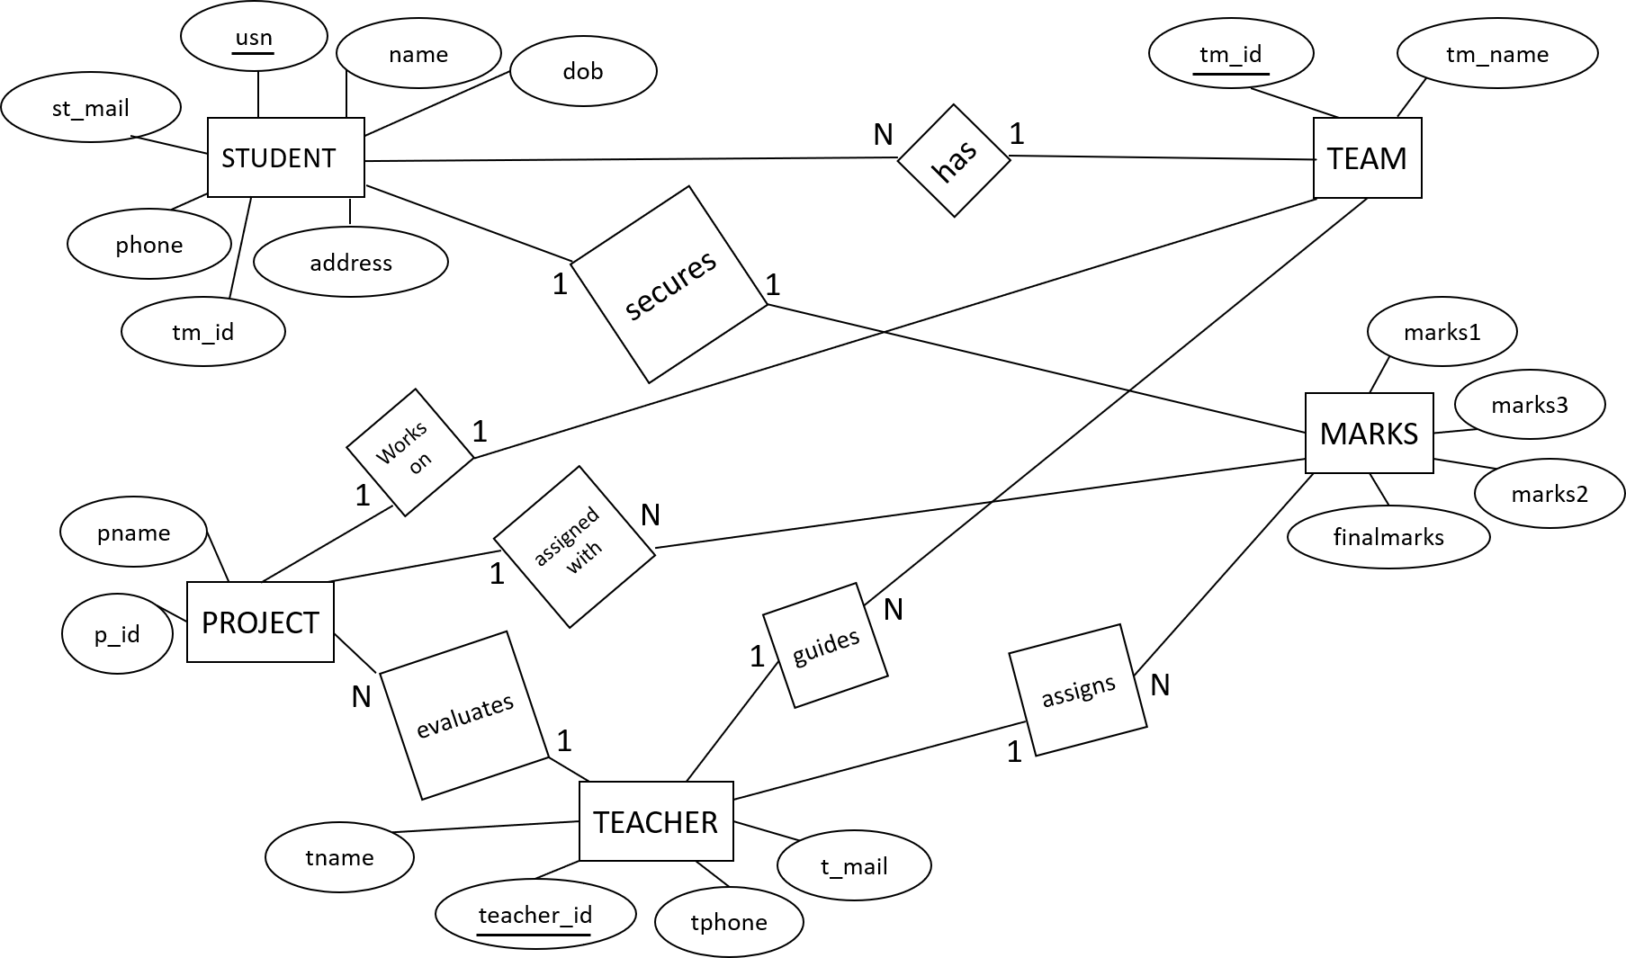

Figure 2.2. ER Diagram

An Entity-Relationship Diagram (ERD) is a data modelling technique that graphically illustrates an information system’s entities and the relationships between those entities. An ERD is a conceptual and representational model of data used to represent the entity framework infrastructure.

The ER Diagram shown in Figure 2.2 consists of 5 entities namely
- PROJECT
- TEACHER
- TEAM
- STUDENT
- MARKS

The PROJECT consists of the following attributes: pid and pname, where pid is the primary key attribute.

The TEACHER consists of the following attributes: teacher_id, t_name, tphone and t_mail, where teacher_id is the primary key attribute.

The TEAM consists of the following attributes: tm_id, tm_name, pid and teacher_id, where tm_id is the primary key attribute.

The STUDENT consists of the following attributes: usn, name, dob, sphone, address, st_mail, tm_id, where usn is the primary key attribute.

The MARKS consists of the following attributes: marks1, marks2, marks3 finalmarks, pid, teacher_id, usn, where pid, teacher_id, usn are the primary key attributes.

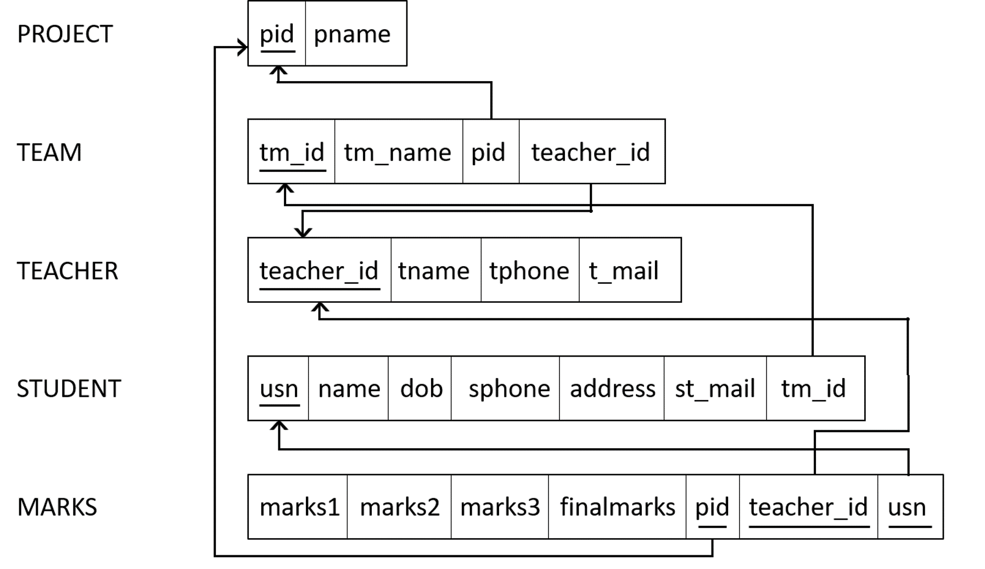
2.3. Schema Diagram

Figure 2.3. Schema Diagram

2.4. Algorithms
Stored procedure:

Step 1: BEGIN
Step 2: CREATE PROCEDURE PROJECT_DB.FMARKS
Step 3: DECLARE AVG, SID, INT;
Step 4: DEFINE C CURSOR FOR
SELECT MARKS1 + MARKS2 + MARKS3 AS AVG, PID FROM MARKS WHERE FINALMARKS IS NULL FOR UPDATE;
Step 5: OPEN C;
Step 6: REPEAT THE FOLLOWING STEP 6
Step 7: FETCH C INTO AVG, SID;
Step 8: UPDATE MARKS SET FINALMARKS=AVG WHERE PID=SID;
Step 9: CLOSE C;
Step 10: END

Trigger:

Step 1: BEGIN
Step 2: CREATE TRIGGER PROJECT_DB.MARKSTRIG
Step 3: BEFORE INSERT ON PROJECT_DB.MARKS
Step 4: FOR EACH ROW
Step 5: IF (NEW.MARKS1>10) THEN SIGNAL SQLSTATE ‘0200’ SET MESSAGE_TEXT =’WARNING: MARKS1 > 10’; END IF;
IF (NEW.MARKS2>30) THEN SIGNAL SQLSTATE ‘0200’ SET MESSAGE_TEXT =’WARNING: MARKS2 > 10’; END IF;
IF (NEW.MARKS1>60) THEN SIGNAL SQLSTATE ‘0200’ SET MESSAGE_TEXT =’WARNING: MARKS3 > 60’; END IF;
Step 6: END

CHAPTER 3
MODULE IMPLEMENTATION

To implement this project, MYSQL is used for backend and java is used for frontend (GUI) creation.
Some of the features of java are:
- Simplicity: Java was designed with a small number of language constructs so that programmers could learn it quickly.
- Object-Oriented: Java supports the construction of programs that consists of collection of objects.
- Robust: Java is designed to eliminate certain types of programming errors. Java is strongly typed, which allows extensive compile-time error checking. It does not support memory pointers, which eliminates the possibility of overwriting memory and corrupting data.
- Secure: Java is designed to be secure in a networked environment. The Java run-time environment uses a bytecode verification process to ensure that code loaded over the network does not violate Java security constraints.
- Portable: In addition to supporting architecture neutrality, Java ensures that other implementation-dependent aspects of language specification are eliminated
- Multithreaded: Java supports multiple threads of execution. This makes programming with threads much easier.
- Dynamic Language: Java supports dynamic loading of classes, dynamic compilation, and automatic memory management

3.1. Module Description
The modules included in this project are:

1. Login
INPUT:
Input: username and password.
OUTPUT:

A successful login, shall take the admin/teacher to the respective profile page, else if the login attempt fails, an error message will be displayed.
DESCRIPTION:
Login page provides 2 textboxes to enter username and password, on entering the admin/teacher shall click on login button, on clicking login button, an Event Handler will call the associated method.
If the entered username and password matches with registered details, the admin/teacher will be taken to login page, otherwise error message will be displayed in the same page, and will be asked to enter username and password again.

CODE SNIPPET:

String sql= "select * from userdetails where user_name= '" + inUser1.getText() + "' and password ='" + inPass1.getText() + "'";
try {
pst5=con.prepareStatement(sql);
rs5= pst5.executeQuery();
if (rs5.next()){
this.hide();
new Teacher_fn().setVisible(true);
}
else{

JOptionPane.showMessageDialog(null, "Wrond LoginId and Password Combination !","Access denied",JOptionPane.ERROR_MESSAGE);
}
}catch(SQLException | HeadlessException e){
JOptionPane.showMessageDialog(null, e);

}

2. Teacher Register
INPUT:
Input: Teacher Id, Name, Phone, Mail, Username, Password.
OUTPUT:
A successful registration of a teacher into the system and will be updated into the database.
DESCRIPTION:

Registration page provides 6 textboxes to enter id, name, phone, mail, username and password, on entering details, teacher shall click on submit button. On clicking submit button, an Event Handler will call the associated method.
If the teacher id already exists in database, an error message will be displayed in the same page and will be asked to enter details again.

CODE SNIPPET:

String sql1="insert into teacher (teacher_id, tname,tphone, t_mail) values(?,?,?,?)";
String sql2="insert into userdetails(user_name,password) values(?,?)";

pst1=con.prepareStatement (sql1);
pst1.setString(1, t_id.getText());
pst1.setString(2, t_name.getText());
pst1.setString(3, t_phone.getText());
pst1.setString(4, t_mail.getText());
pst1.execute();

pst2=con.prepareStatement(sql2);
pst2.setString(1, username.getText());
pst2.setString(2, pass.getText());
pst2.execute();

JOptionPane.showMessageDialog(null, "Succesfully Registered");

3. View Marks
INPUT:
Input: Project Id.
OUTPUT:
Team id, Project Id, Teacher Id and Marks with respective to the inputted Project Id in the form of jTable.
DESCRIPTION:
This page provides a textbox in which student can enter their project id to view the marks which has been allotted to their project. On clicking search button, an Event Handler will call the associated method.
If the project id doesn’t exist in database, an error message will be displayed in the same page and will be asked to enter details again.

CODE SNIPPET:

String sql1="select T.pid,T.tm_id,T.teacher_id,M.finalmarks from\n"
+ "project P,team T,marks M\n"
+ "where P.pid=T.pid and P.pid=M.pid and P.pid='"+gpid.getText()+"'";
DefaultTableModel tb=(DefaultTableModel) outputtable.getModel();
tb.setRowCount(0);
try
{
String rg[]=new String[4];
pst4=con.prepareStatement(sql1);
rs2= pst4.executeQuery();
if(rs2.next())
{
do
{
rg[0]=rs2.getString(1);
rg[1]=rs2.getString(2);
rg[2]=rs2.getString(3);
rg[3]=rs2.getString(4);
tb.addRow(rg);
}while(rs2.next());
}
}

4. Insert Student
INPUT:
Input: USN, Name, DOB, Phone, Address, Email, Team Id.
OUTPUT:
A successful insertion of a student into the system and will be updated into the database.
DESCRIPTION:
Registration page provides 7 textboxes to enter USN, Name, DOB, Phone, Address, Email, Team Id.
On entering details, admin shall click on submit button. On clicking submit button, an Event Handler will call the associated method. If the USN already exists in database, an error message will be displayed in the same page and will be asked to enter details again.

CODE SNIPPET:

try{

String sql1="insert into student(usn,name,dob,sphone,address,st_mail,tm_id) values(?,?,?,?,?,?,?)";

pst1=con.prepareStatement(sql1);
pst1.setString(1,susn.getText());
pst1.setString(2,sname.getText());
pst1.setString(3,dob.getText());
pst1.setString(4,phone.getText());
pst1.setString(5,add.getText());
pst1.setString(6,smail.getText());
pst1.setString(7,idteam.getText());

pst1.execute();

JOptionPane.showMessageDialog(null, "Succesfully Registered");
}

5. Insert Project and Team
INPUT:
Input: Team Id, Team name, Project Id, Project Name, Teacher Id.
OUTPUT:
A successful insertion of a team and project into the system and will be updated into the database.
DESCRIPTION:
Registration page provides 5 textboxes to enter Team Id, Team name, Project Id, Project Name, Teacher Id. On entering details, admin shall click on submit button. On clicking submit button, an Event Handler will call the associated method.
If the Team Id and Project Id already exists in database, an error message will be displayed in the same page and will be asked to enter details again.

CODE SNIPPET:

try{
String sql1="insert into team(tm_id,tm_name,pid,teacher_id) values(?,?,?,?)";
String sql2="insert into project(pid,pname) values(?,?)";

pst6=con.prepareStatement(sql1);

pst6.setString(1,tmid.getText());
pst6.setString(2,tmname.getText());
pst6.setString(3,id_proj.getText());
pst6.setString(4,teacher_id.getText());
pst6.execute();

pst7=con.prepareStatement(sql2);
pst7.setString(1,id_proj.getText());

pst7.setString(2,proj_name.getText());
pst7.execute();

JOptionPane.showMessageDialog(null, "Succesfully Registered");
}

6. View Projects
INPUT:
Input: Button Click Event.
OUTPUT:
All Team Id, Team name, Project Id, Project name, and Marks in the form of jTable.
DESCRIPTION:
This page provides a refresh button to view the details mentioned above from the database. On clicking view projects button, an Event Handler will call the associated method.

CODE SNIPPET:

String s="select T.tm_id,T.tm_name,P.pid,P.pname,M.finalmarks\n" +
"from team T,project P,marks M\n" +
"where P.pid=T.pid and P.pid=M.pid";

DefaultTableModel tb=(DefaultTableModel) viewproj.getModel();
tb.setRowCount(0);
try
{
String rg[]=new String[5];
pst2=con.prepareStatement(s);
rs1= pst2.executeQuery();

if(rs1.next())
{
do

{
rg[0]=rs1.getString(1);
rg[1]=rs1.getString(2);
rg[2]=rs1.getString(3);
rg[3]=rs1.getString(4);

rg[4]=rs1.getString(5);

tb.addRow(rg);

}while(rs1.next());
}

7. View Teachers
INPUT:
Input: Button Click Event.
OUTPUT:
All Teacher id, Teacher name, Project Id, Team the form of jTable.
DESCRIPTION:
This page provides a refresh button to view the details mentioned above from the database. On clicking view teachers button, an Event Handler will call the associated method.

CODE SNIPPET:

String s="select teacher_id,tname,tphone,t_mail\n" +
"from teacher\n";

DefaultTableModel tb=(DefaultTableModel) teacher_view.getModel();
tb.setRowCount(0);
try
{
String rg[]=new String[4];
pst8=con.prepareStatement(s);
rs8= pst8.executeQuery();

if(rs8.next())
{
do
{
rg[0]=rs8.getString(1);
rg[1]=rs8.getString(2);
rg[2]=rs8.getString(3);

rg[3]=rs8.getString(4);

tb.addRow(rg);

}while(rs8.next());

}
}

8. Insert Marks
INPUT:
Input: Marks1, Marks2, Marks3.
OUTPUT:
A successful insertion of a final marks into the system and will be updated into the database.
DESCRIPTION:
Input page provides 7 textboxes to enter Marks1, Marks2, Marks3, Team Id, Teacher Id, Username and Password. On entering details, teacher shall click on submit button. On clicking submit button, an Event Handler will call the associated method.
A Stored Procedure will be called which will calculate final marks by adding all three marks and will insert into the database.

CODE SNIPPET:

String selectquery="insert into marks(marks1,marks2,marks3,finalmarks,pid,teacher_id) values(?,?,?,?,?,?)";
pst1=con.prepareStatement(selectquery);
pst1.setString(1,marks1.getText());
pst1.setString(2,marks2.getText());
pst1.setString(3,marks3.getText());
pst1.setString(4,"");
pst1.setString(5,p_id.getText());
pst1.setString(6,teacher_id.getText());

pst1.execute();
cs=con.prepareCall("{ call fmarks}");
cs.executeUpdate();
JOptionPane.showMessageDialog(null, "Marks Updated");

9. View Projects and Marks allotted
INPUT:
Input: Teacher Id.
OUTPUT:

Team id, Project Id, Teacher Id and Marks with respective to the inputted Project Id in the form of jTable.
DESCRIPTION:
This page provides a textbox in which teacher can enter their id to view the details which has been allotted to their project. On clicking search button, an Event Handler will call the associated method.
If the teacher id doesn’t exist in database, an error message will be displayed in the same page and will be asked to enter details again.

CODE SNIPPET:

String sql1="select T.tm_id,T.tm_name,T.pid,P.pname,M.finalmarks from\n"
+ "project P,team T,marks M\n"
+ "where P.pid=T.pid and M.pid=P.pid and M.teacher_id='"+teacher_id.getText()+"'";
DefaultTableModel tb=(DefaultTableModel) viewteam.getModel();
tb.setRowCount(0);
try
{
String rg[]=new String[5];
pst5=con.prepareStatement(sql1);
rs5= pst5.executeQuery();

if(rs5.next())
{
do
{
rg[0]=rs5.getString(1);
rg[1]=rs5.getString(2);
rg[2]=rs5.getString(3);
rg[3]=rs5.getString(4);
rg[4]=rs5.getString(5);
tb.addRow(rg);
}while(rs3.next());
}
}

CHAPTER 4
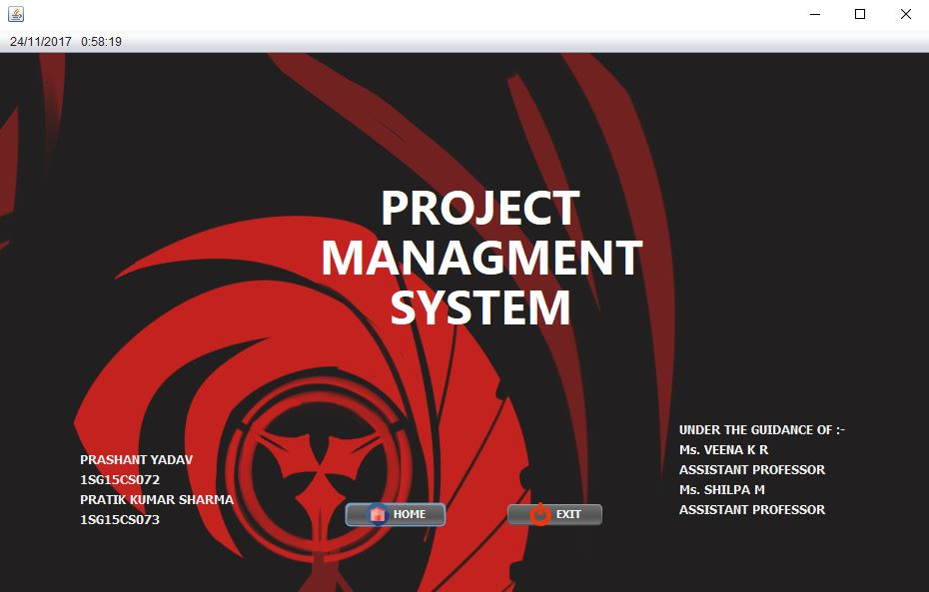
RESULTS AND SCREENSHOTS
Figure 4.1. Introduction Page

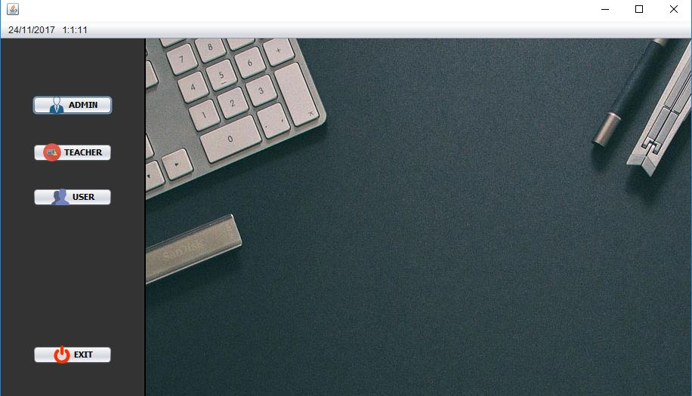
Figure 4.2. Home Page

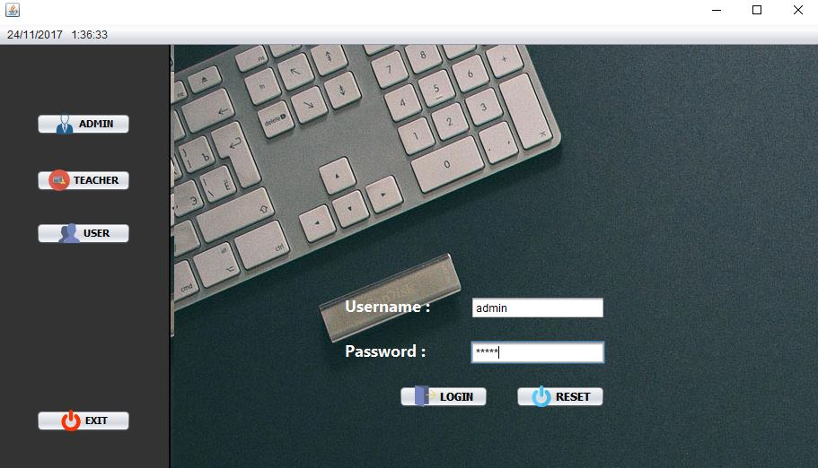Figure 4.3. Admin Login Page

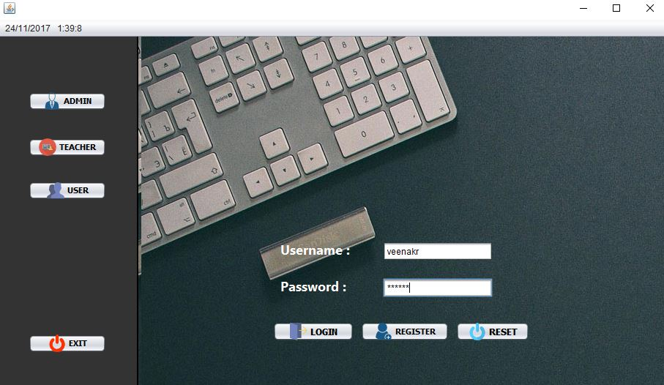Figure 4.4. Teacher Login Page

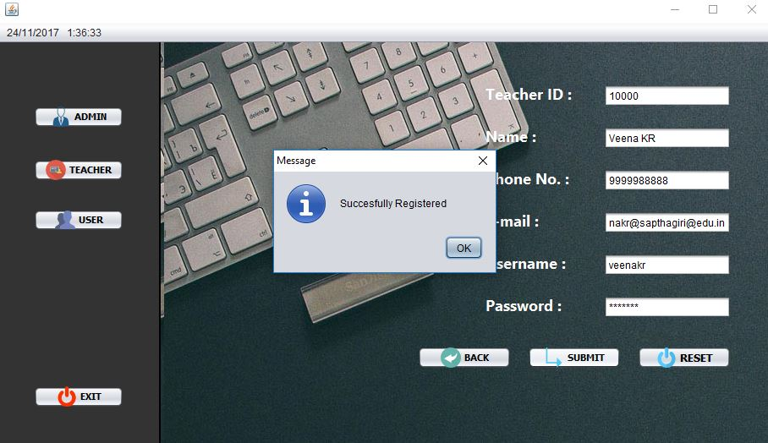Figure 4.5. Teacher Registration Page

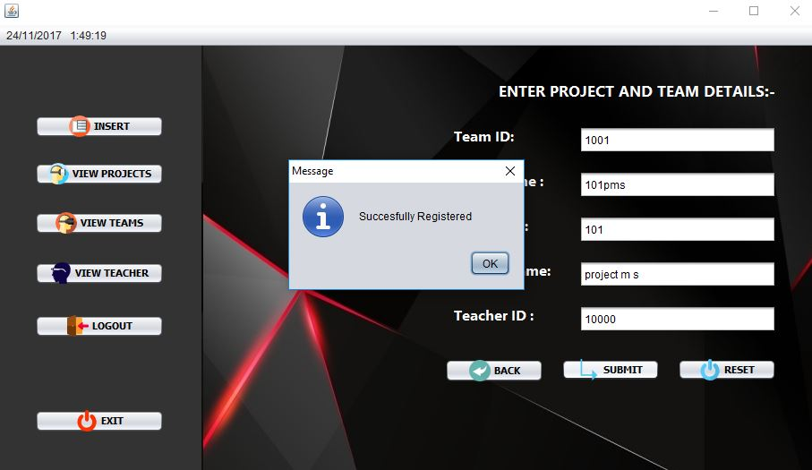
Figure 4.6. Insert Project

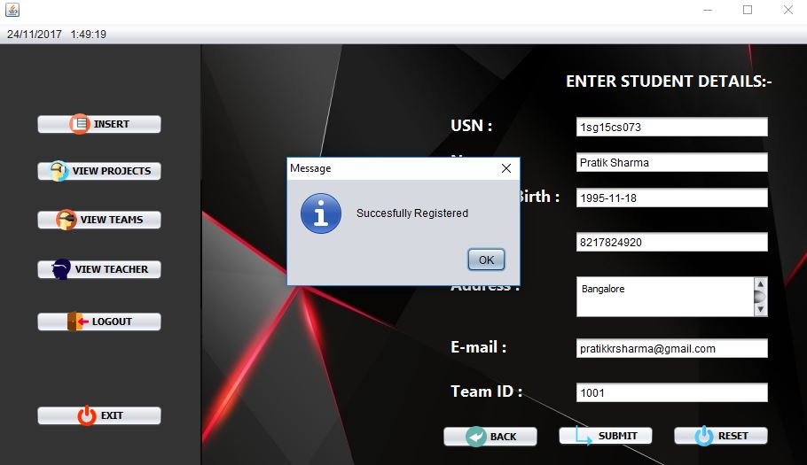
Figure 4.7. Insert Student

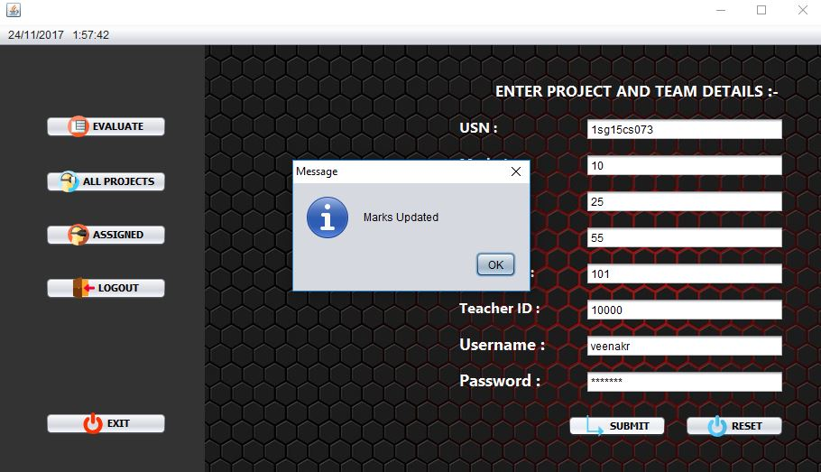Figure 4.8. Insert Marks

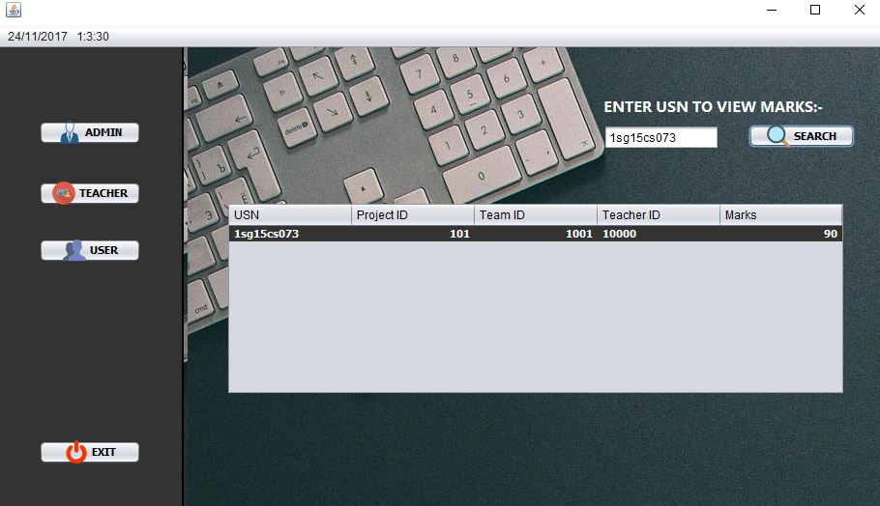
Figure 4.9. View Marks

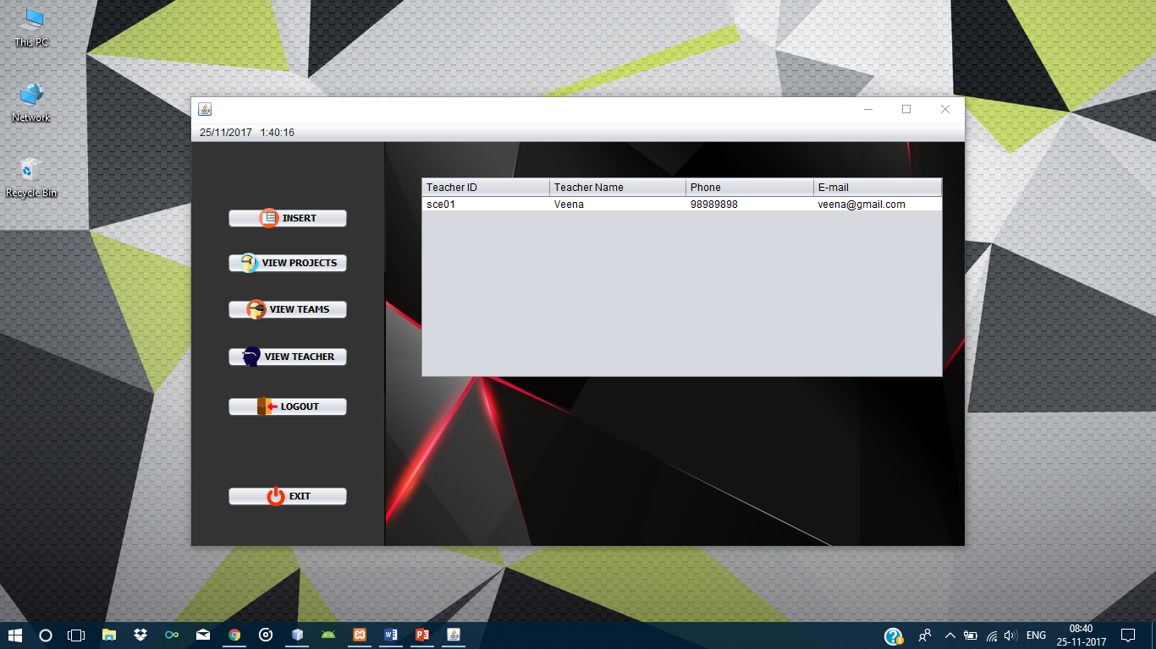Figure 4.10. View Teachers

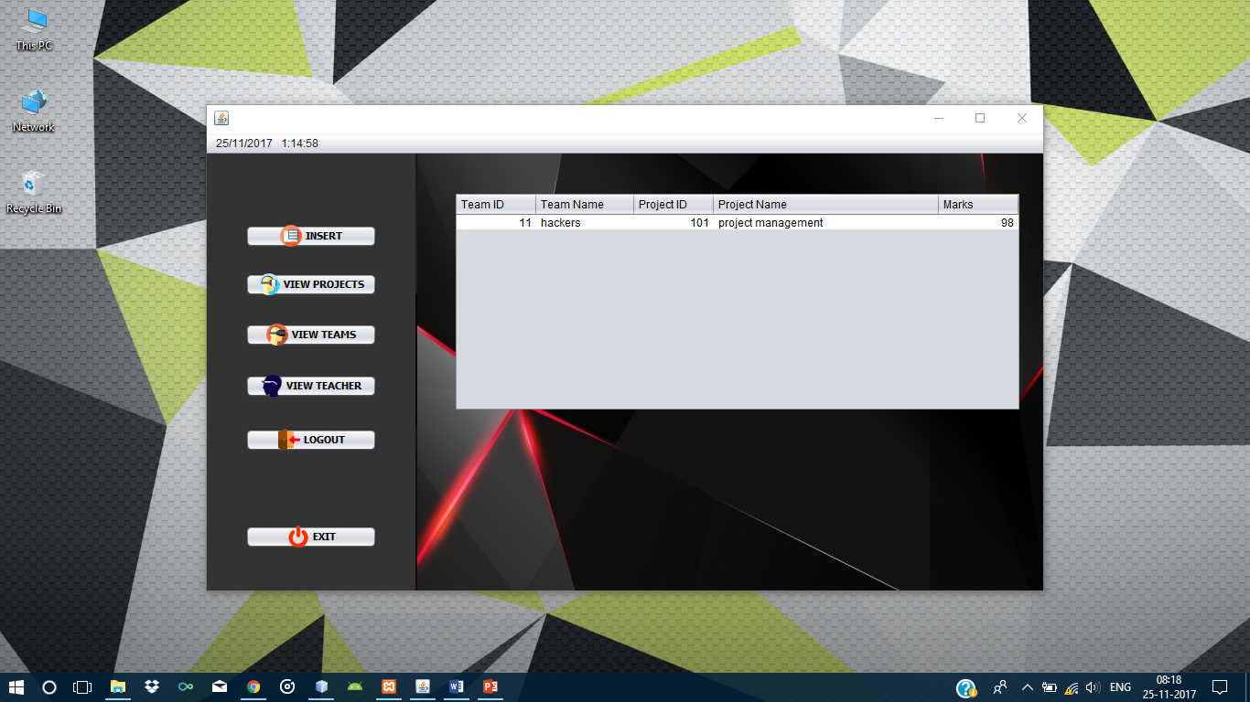
Figure 4.11. View Projects

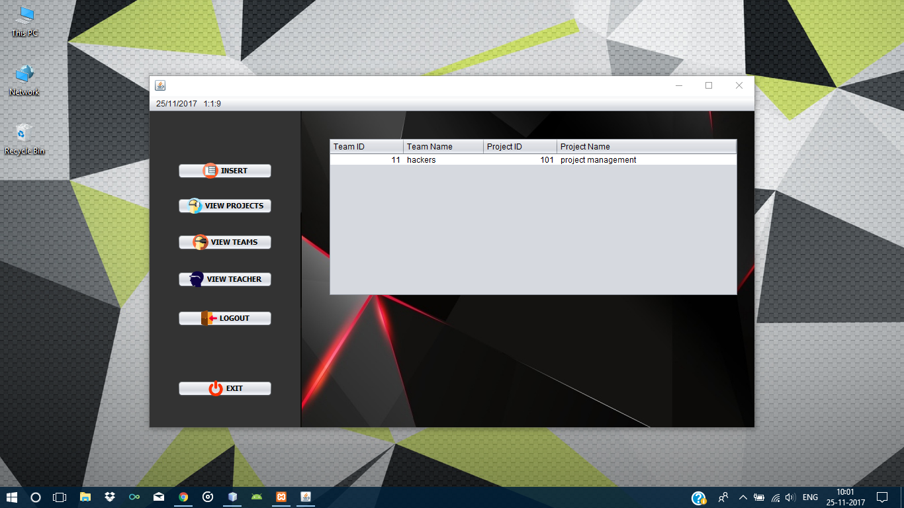
Figure 4.12. View Teams

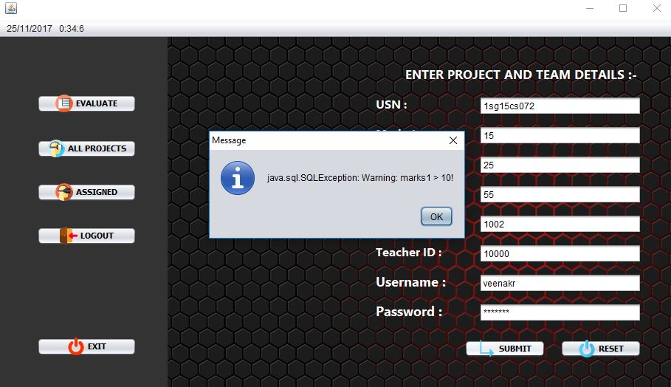
Figure 4.13. Trigger

CHAPTER 5
CONCLUSION AND FUTURE WORKS
Conclusion:
This work is a humble venture to satisfy all the needs of an institution to manage their data digitally. Several user-friendly codes have been adopted. Simple interface has been provided to make it user friendly.
It can be used by any institution who wants to transfer their database to digital storage or any cloud server, thus making maintenance of data more reliable and reducing overall redundancy which is more in non-digital ways of storage.
This project shall prove to be a powerful package which satisfies all the requirements of an institution for storing and maintaining the projects undertaken by them.

Future works:
- The project shall be transformed into a website, storing database on online servers to make is accessible worldwide.

Bibliography

[1] Fundamentals of Database Systems, Ramez Elmasri and Shamkant B. Navathe, 7th Edition, 2017, Pearson
[2] www.stackoverflow.com
[3] www.youtube.com
[4] www.scribd.com
[5] www.tutorialpoint.com
[6] www.flaticons.com
[7] www.mariadb.org
[8] Database management systems, Ramakrishnan, and Gehrke, 3rd Edition 2014, McGraw Hill
[9] Jim Keogh: J2EE-TheCompleteReference, McGraw Hill, 2007

